MYSQL ASSIGNMENT

Tables Created here

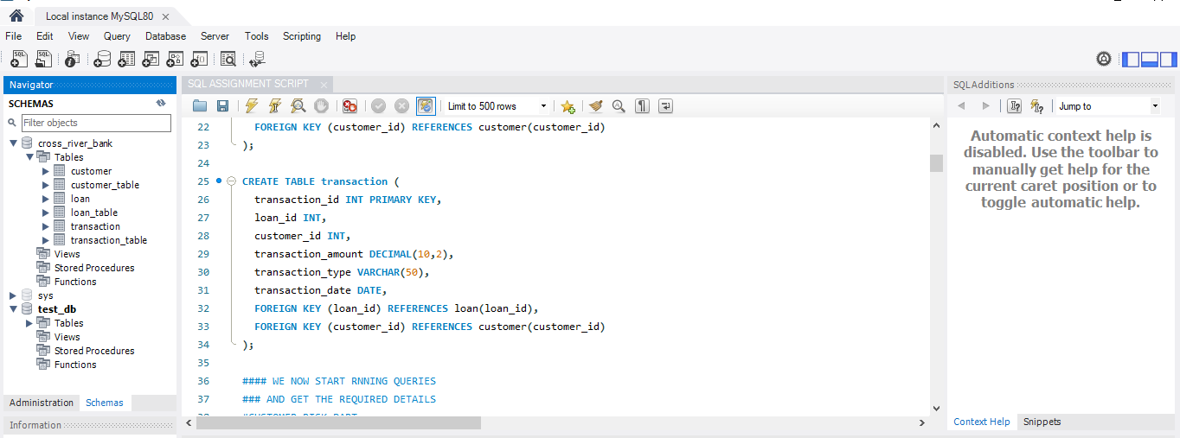The tables were manually uploaded- the tables are customertable, loan_table and transaction_table- in cross river bank db

In Mongo DB The databases are created as follows

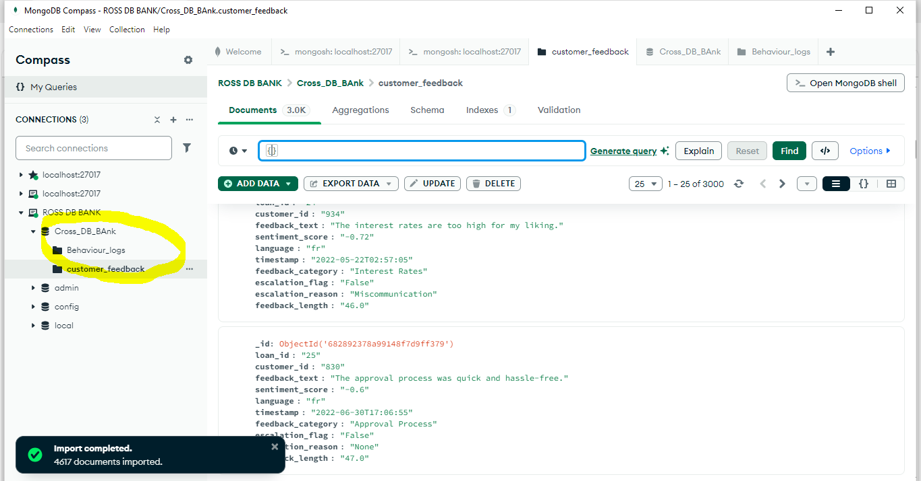

1. Customer Risk Analysis: Identify customers with low credit scores and high-risk loans to predict potential defaults and prioritize risk mitigation strategies. BASIC

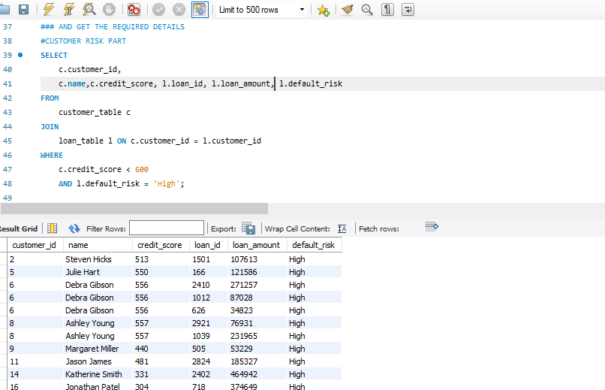

1. Loan Purpose Insights: Determine the most popular loan purposes and their associated revenues to align financial products with customer demands. BASIC

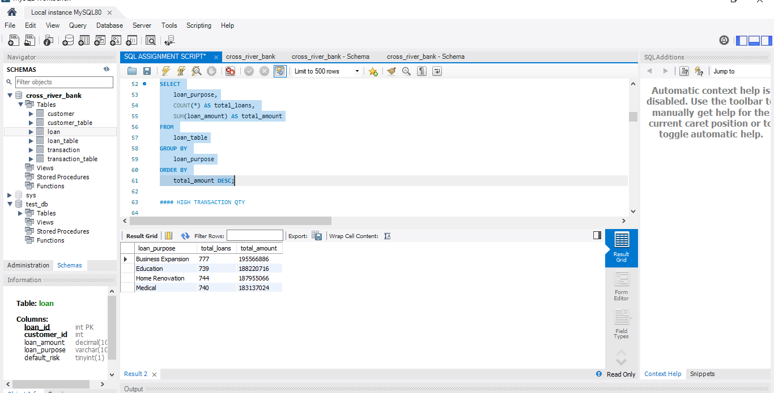

1. High-Value Transactions: Detect transactions that exceed 30% of their respective loan amounts to flag potential fraudulent activities. BASIC

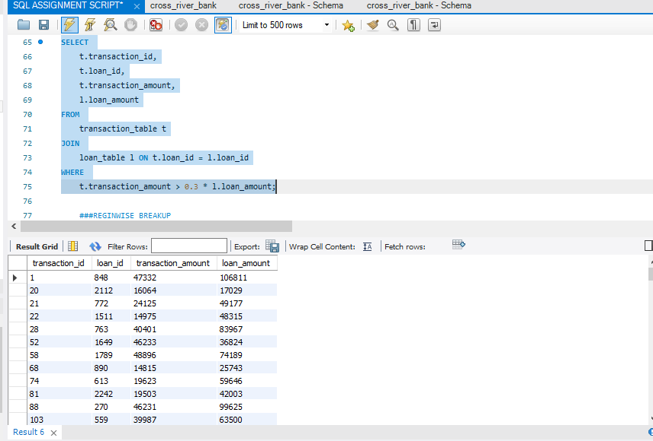

● Missed EMI Count: Analyze the number of missed EMIs per loan to identify loans at risk of default and suggest intervention strategies. BASIC

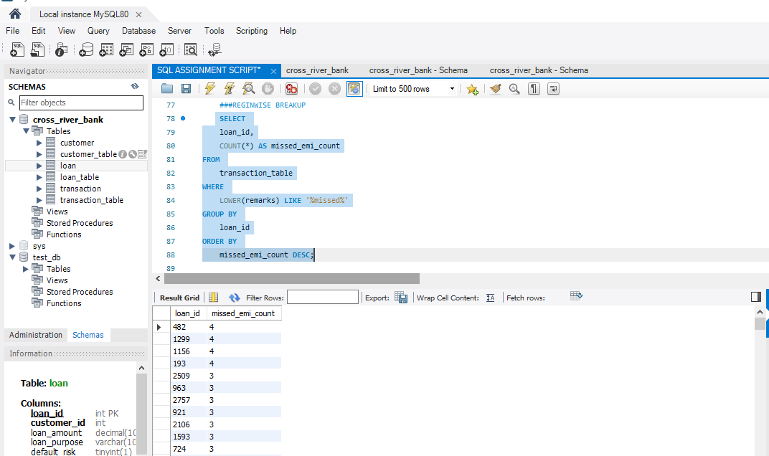

Regional Loan Distribution: Examine the geographical distribution of loan disbursements to assess regional trends and business opportunities. INTERMEDIATE

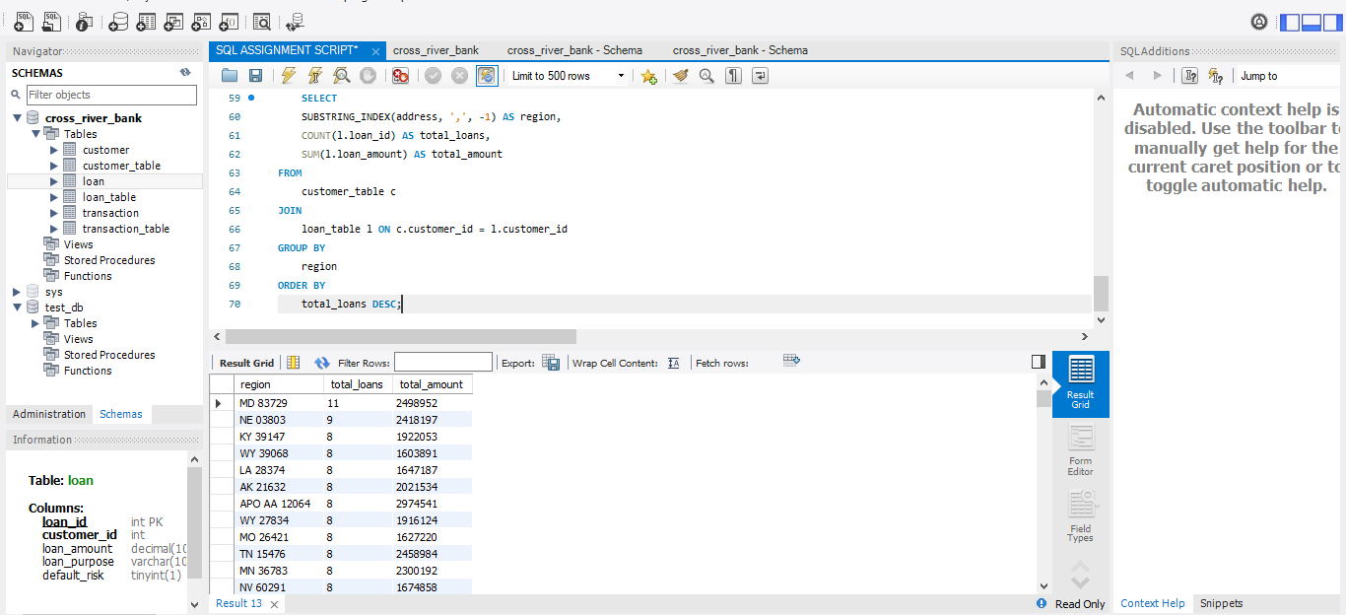

● Loyal Customers: List customers who have been associated with Cross River Bank for over five years and evaluate their loan activity to design loyalty programs. INTERMEDIATE

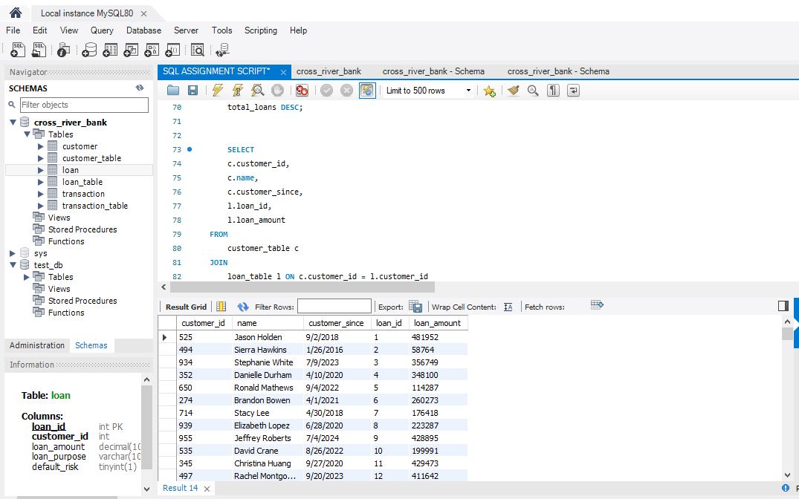

High-Performing Loans: Identify loans with excellent repayment histories to refine lending policies and highlight successful products. INTERMEDIATE

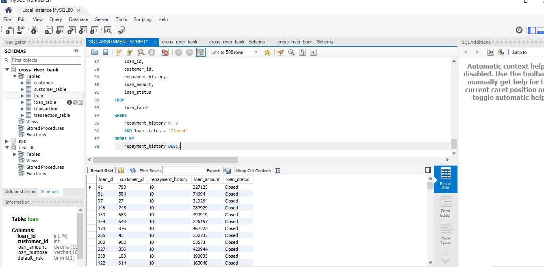

Age-Based Loan Analysis: Analyze loan amounts disbursed to customers of different age groups to design targeted financial products. INTERMEDIATE

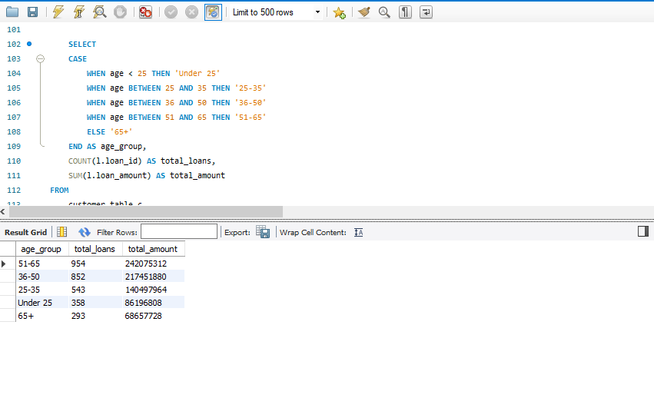

Seasonal Transaction Trends: Examine transaction patterns over years and months to identify seasonal trends in loan repayments. Advanced

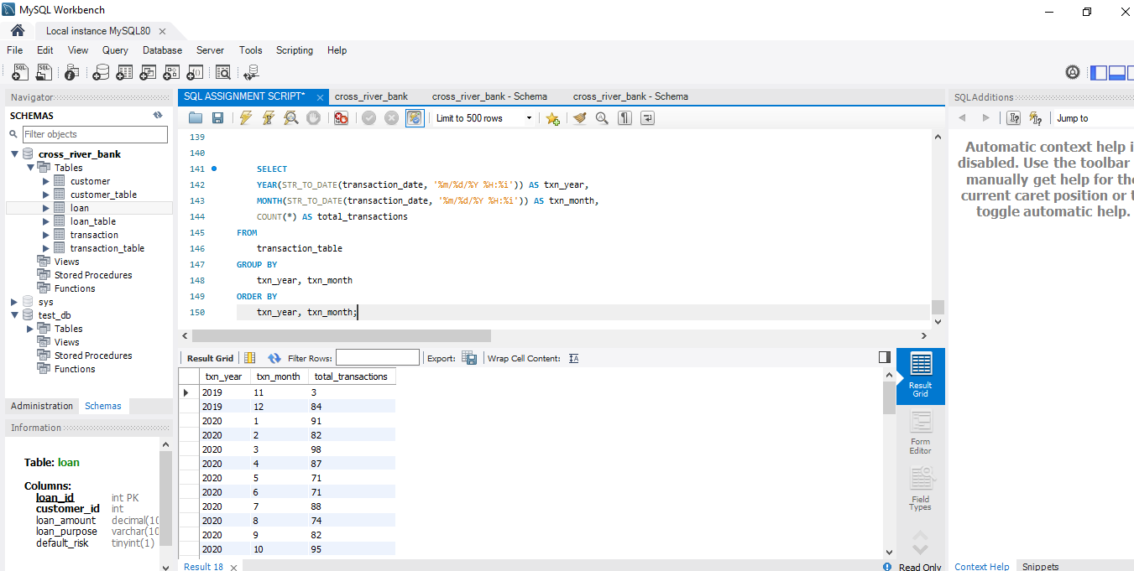

Fraud Detection: Highlight potential fraud by identifying mismatches between customer address locations and transaction IP locations. Advanced

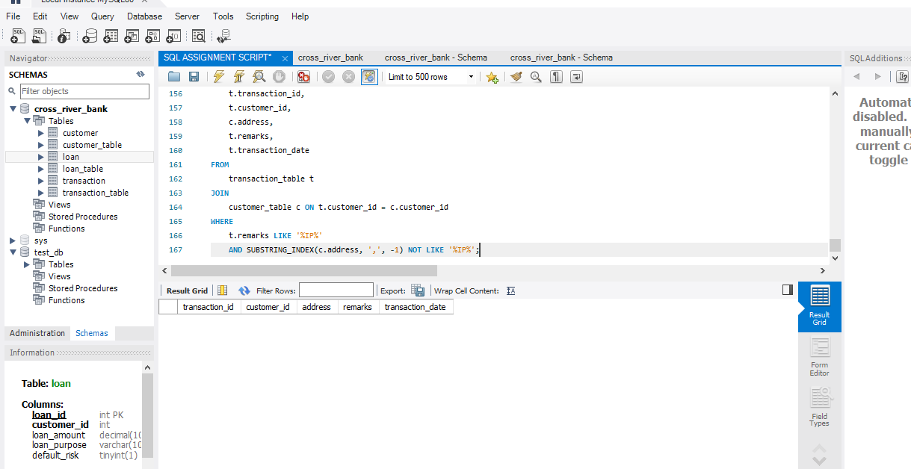

Repayment History Analysis: Rank loans by repayment performance using window functions. Advanced

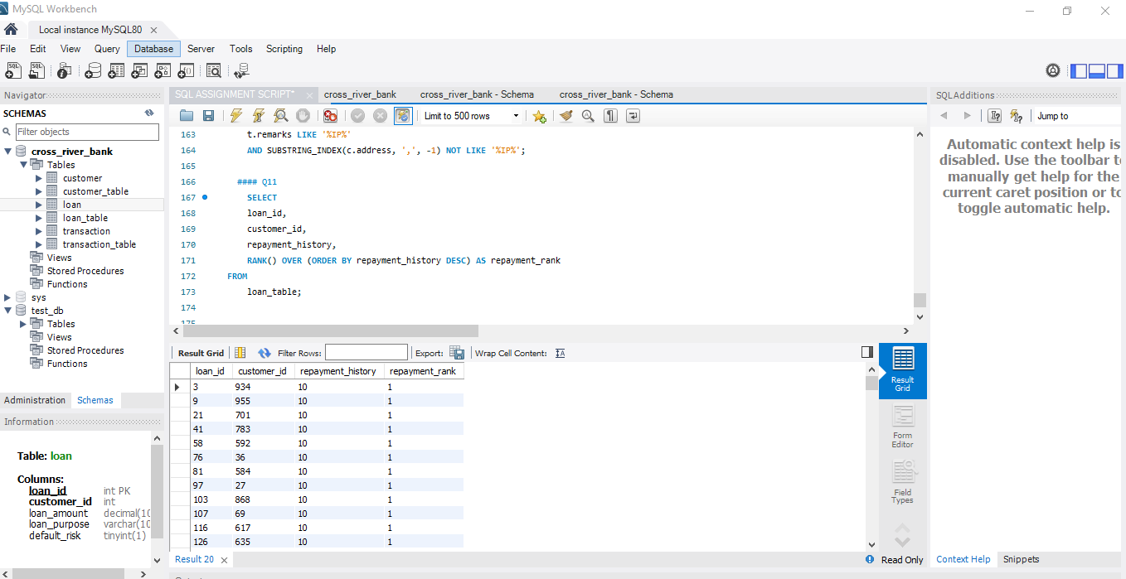

Credit Score vs. Loan Amount: Compare average loan amounts for different credit score ranges. Advanced

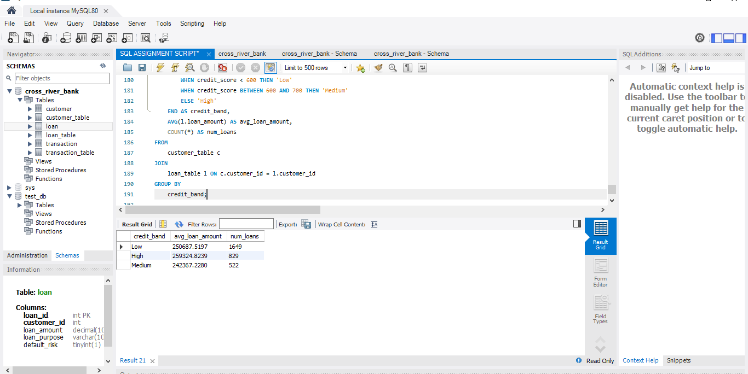

Top Borrowing Regions: Identify regions with the highest total loan disbursements. Advanced

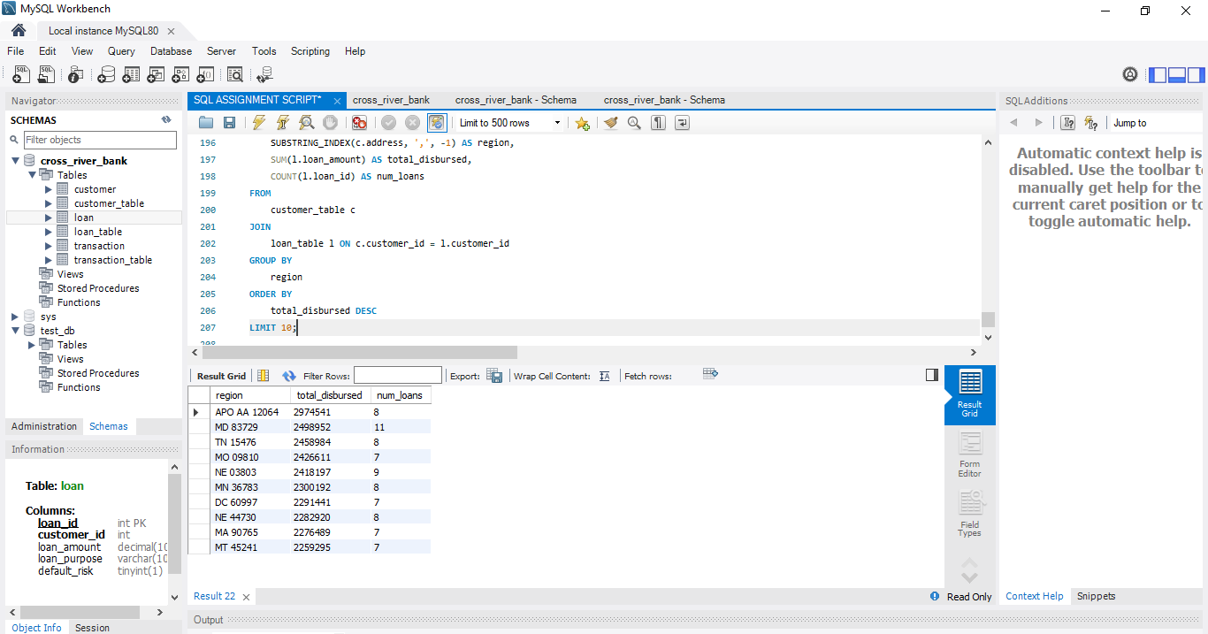

Early Repayment Patterns: Detect loans with frequent early repayments and their impact on revenue. Advanced

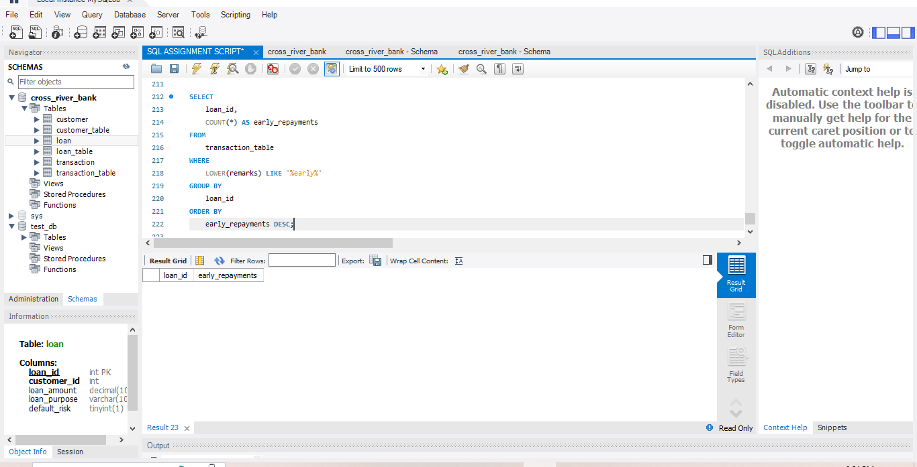

MongoDB Questions

